ITEMS OF INTEREST MARCH 2026

Remember in your prayers: Verna Schultz, Arlys Thompson, Mary Lou Meyer, Ardis Brehmer, Rita Hillman, Jeanette Bohlman, Elaine Gerber, Joyce Nelson, Dennis Schnaser, Elroy & JoAnn Adermann, Deanna Jensen, Jim Scheff, Arvid Knutson, David Schwarze, Josh Miller, Brian Baerwaldt, Myles Maas, Carol Dragt, & Marlyce Thompson.

Sarah-Ann Circle will meet on Wednesday, March 18th at 9:30 am. Kathy Rabe and Ila Rae Kaufman are the hostesses. Please join us for Bible Study and refreshments.

Lent Schedule:
3/11 6 PM Lenten Service
4/2 6 PM Maudy Thursday (Communion Service)
4/3 12:15-12:45 PM Good Friday Noon Service
4/5 9 AM Easter Sunday Service

Easter Flowers: If you are donating an Easter lily or flower for the Easter Garden, please have them at the church by Friday, April 3rd. Please make sure to indicate who the flower is in memory of.
Thank you, Altar Circle

Brian Baerwaldt shared he is feeling better and welcomes anyone who would like to call him to please call his cell: 1-605-956-0627

Please leave the church unlocked if there is an event later in the afternoon or evening. There is a calendar in the coat room. Thank You!

Trinity is having to install three new furnace/AC units.
The Trustees are encouraging anyone who would like to contribute to please write their checks out to Trinity Lutheran Church and add to the memo and the outside of their envelope-Furnace Fund. The more money the church can raise the less that needs to be borrowed.
Thank you for your contribution,
The Board of Trustees

Current List of Designated Memorials:
Defibrillator Fund Pew Fund Lutheran Braille Workers
Furnace/AC Fund Music Fund Window Repair Fund
Lighting/Audio/Video Camera Fund

Change of Address
Gary & Monica Voegtli
217 Lundell Street Apt #145
Ortonville, MN 56278
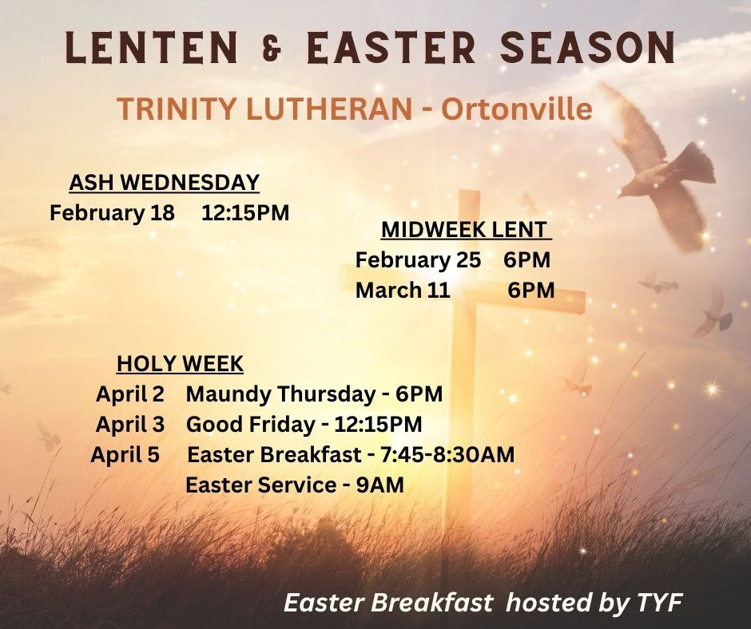





“OUR SAVIOR’S WOUNDED BODY…FOR US!”

Lent 2026 – Emanuel Lutheran Church

*Wednesday Services are at 2:00 pm and 7:00 pm
Supper at 5:00 pm

2/18 *Ash Wednesday – His Humbled head
2/25 *Lent #2 – His Holy Hands
3/4 *Lent #3 – His Battered Back
3/11 *Lent #4 – His Faithful Feet
3/18 *Lent #5 – The Savior’s Side
3/25 *Lent #6 – His Unbroken Bones

4/2 6:30 pm Maundy Thursday – His Holy Blood
4/3 3:00/6:30 pm Good Friday – The Light
4/4 6:30 pm Easter Vigil – From Death to Life
4/5 6:30/9:00 am Easter Morning – Who’s
Wounded Now (breakfast between services)

Thrivent Action

Teams provide up to $250 in seed money (twice a year) to Thrivent policy holders to support a community/churchly project. The money can be used for a fundraiser, service activity, or educational event. This doesn't mean you have to assemble a team to use this money, but rather this money is spent towards a charitable cause of your choosing, which a single person can purchase with the $250 they load onto a Visa gift card.
How it works
- Apply for a Thrivent Action Team online
- If approved, receive a Thrivent Action Team Kit, which includes a $250 Community Impact Card
- Use the card to purchase supplies and create promotional materials
- Complete the project within 90 days
- Complete an online report on the project
What can I do with the money? Organize a school supply drive, Host a car wash fundraiser, Plan a dinner, Purchase books for a mission trip, and Pay for meals or travel expenses.
Who can apply? Thrivent policy holders and Members of Thrivent Financial.



